Rudy2 – Trailers, Pigs, and New Friends Crossword
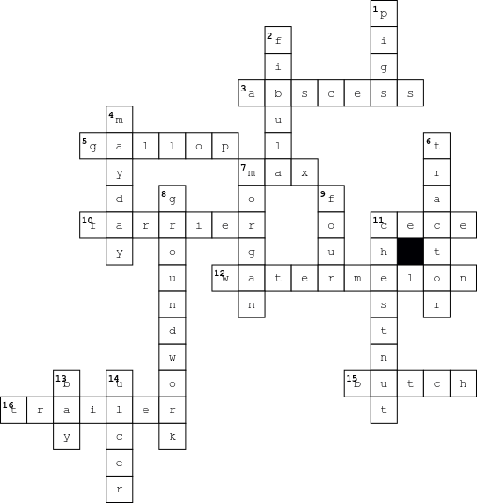

Across  3. Injury to Rudy's hoof  5. The horses fastest gate  7. Horse that bullied Rudy  10. Person who trims horse's hooves  11. Rudy's Mom's niece  12. Rudy's favorite fruit  15. Rudy's farrier  16. The box on wheels Rudy doesn't like |  | Down  1. Animal Rudy is afraid of  2. The bone Rudy's Mom broke  4. Rudy's new friend  6. What hit the rock that frightened Rudy causing Diane to fall off  7. Max's breed  8. Training when the person is on the ground  9. The number of pigs at the barn  11. The color of Rudy's hair  13. The color of Mayday's hair  14. The problem Rudy had with his stomach

